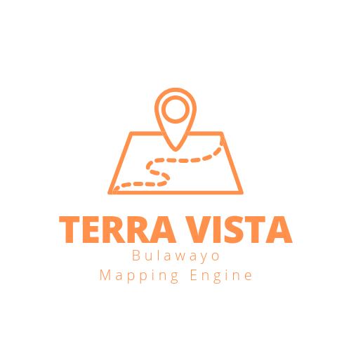

**TERRA VISTA BULAWAYO MAPPING AND SURVEYING ENGINE INSTALLATION AND USER GUIDE**

Terra Vista clients and users do not have to go through the tedious task of installing the app and the long hours needed to downlaod these softwares. The software engine is loaded on a streamlit cloud server so all Terra Vista Engine dependencises are found online thus the engine can only be used while online to fully achieve its capabilities.

The framework of the engine is like this:

1. The engine is designed and uploaded to the Mthoe Saps Construction Technologies github repository with a virtual environment full of the engines dependencies that is no downlaods will be made by the users.

2. The repo is then accesed by the Engine hosting cloud which is streamlit and that is where the users will then access the engine.

3. The users or clients of the engine will receive a link from the Developer’s (Mthokozisi Thabiso Sapuwa) email to access the engine.

4. Users/ clients will then click on the link and use the engine any time they need to at their own convenience. The engine comes with an installation option to install the engine link to you computer or phone and then access it without having to navigate to the email directory all the time.

**USER TUTORIAL**

The software allows users to interact with the maps, download and manipulate the data, and add other combined elements to view multiple datasets simultaneously, it showcases advanced interactivity and flexibility in data exploration and analysis.

We describe it as an “interactive mapping and data visualization platform” or a “dynamic geospatial data analysis engine.” It goes beyond basic mapping functionalities by empowering users to actively engage with the data, customize the visualizations, and perform additional analysis by combining multiple datasets.

The ability to download and manipulate the data indicates that the software provides data export capabilities and potentially supports data transformations or analysis operations that the users to manipulate the data according to their needs.

As stated above, Terra Vista is a comprehensive mapping software with additional data processing and visualization capabilities by allowing users to upload Excel files, processing the data, and rendering it on both 2D and 3D maps, as well as plotting charts on a separate tab, Terra Vista offers a range of functionalities for data exploration, analysis, and visualization in the context of mapping. It combines data processing, mapping, and charting capabilities into a single application, providing users with a comprehensive toolset for working with geospatial data.